- Connect the SMART-BRIDGE 10 to the app.
- Click 3 time on test button on Smart-Smoke 10 (The LED should be on)
- Click on Add sub

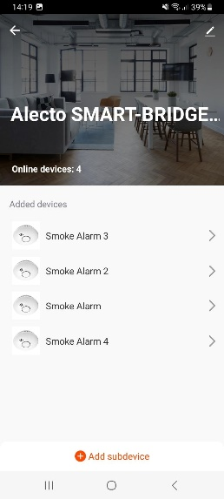

- Click on LED already blink

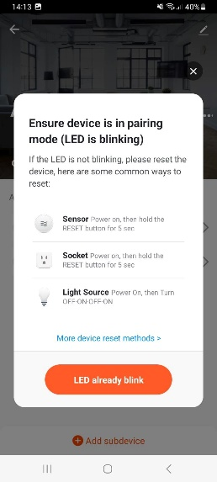

- Searching

- Device have been successfully added

- Done

